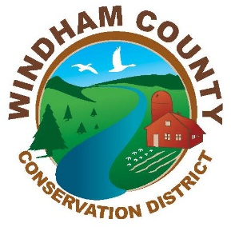
2021 Aquatic Invasive Species Greeter Program
Application for Employment

Name: _____________________________________________________
Telephone you can be reached at: ______________________________
Address ____________________________________________________
Email Address _______________________________________________
What experience, if any, do you have working with invasive species?

Would you be comfortable working long hours outdoors in the elements (insects, heat, cold, rain)?

Are there any dates that you would be unable to work between May 28 and September 15? (please list)

Would you be interested in working as a substitute greeter (limited days) if regular positions have been filled?

Which water bodies are you willing to work at: (circle all)

Somerset Reservoir Lake Raponda

Please provide two professional references (not related to you):

1.
Name:
Relationship to You:
Phone:
Email:
2.
Name:
Relationship to You:
Phone:
Email:

Please send via email along with a resume or letter highlighting your relevant skills and experience to Windham Conservation District Manager Cory Ross at ross.wcnrcd@gmail.com

